**PRACTICAL No.8**

**AIM: Write a Program to calculate a/b + c/d**

**STEPS:**

#Write a Program to calculate a/b + c/d.

a=int(input("Enter first number: "))

b=int(input("Enter second number: "))

c=int(input("Enter third number: "))

d=int(input("Enter fourth number: "))

num=(a/b + c/d)

print(num)

_______________________________________________________________________________________________________________________________________________________________________________________________________________________________________________________________________________________________________________________________________________________________________________________________________________________________________________________________________________________________________________________________________________________________________________________________________________________________________________________________________________________________________________________________________________________________________________________________________________________________________________________________

**SCREENSHOT:**

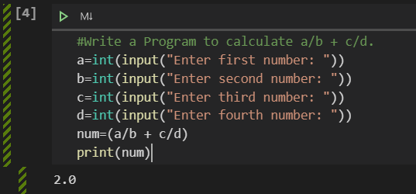

**Date:**